Batch: B1 Roll No.: 1711072

Experiment / assignment / tutorial No. 2

Grade: AA / AB / BB / BC / CC / CD /DD

Signature of the Staff In-charge with date

TITLE: To study and implement Booth’s Multiplication Algorithm.

AIM: Booth’s Algorithm for Multiplication
______________________________________________________________________
Expected OUTCOME of Experiment:

CO 2-Detail working of the arithmetic logic unit and its sub modules
_____________________________________________________________________
Books/ Journals/ Websites referred:

- Carl Hamacher, Zvonko Vranesic and Safwat Zaky, “Computer Organization”, Fifth Edition, TataMcGraw-Hill.
- William Stallings, “Computer Organization and Architecture: Designing for Performance”, Eighth Edition, Pearson.
3. Dr. M. Usha, T. S. Srikanth, “Computer System Architecture and Organization”, First Edition, Wiley-India.
_____________________________________________________________________
Pre Lab/ Prior Concepts:

It is a powerful algorithm for signed number multiplication which generates a 2n bit product and treats both positive and negative numbers uniformly. Also the efficiency of the algorithm is good due to the fact that, block of 1’s and 0’s are skipped over and subtraction/addition is only done if pair contains 10 or 01

Flowchart:

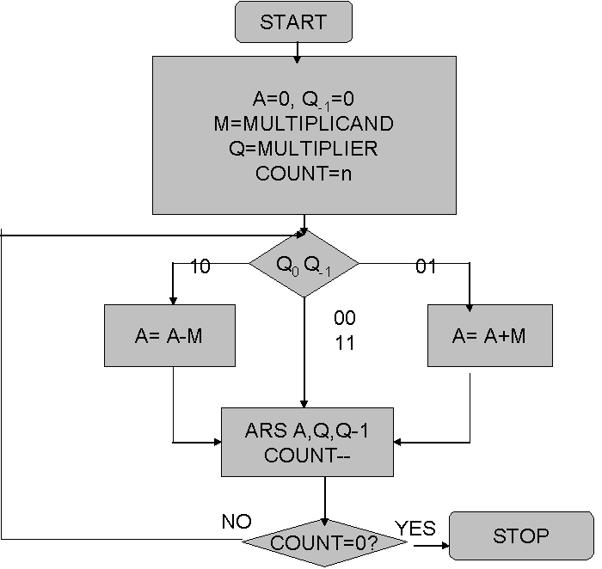

Design Steps:
- Start
- Get the multiplicand (M) and Multiplier (Q) from the user
- Initialize A= Q₋₁ =0
- Convert M and Q into binary
- Compare Q₀ and Q₋₁ and perform the respective operation.
Q₀ Q₋₁ | Operation
00/11 | Arithmetic right shift
01 | A+M and Arithmetic right shift
10 | A-M and Arithmetic right shift

6. Repeat steps 5 till all bits are compared
7. Convert the result to decimal form and display
8. End

Implementation (in Java):
import java.util.*;
class Main {
public static void main(String[] args) {
int M,Q, Q_1=0;
int BITS=5;
int count=BITS;
//int A[]=new int[BITS];
int M_BIN[]=new int[BITS];
int Q_BIN[]=new int[BITS];
int answer[]=new int[BITS];
int M_TEMP[]=new int[BITS];
Scanner sc=new Scanner(System.in);
System.out.println("BOOTH'S ALGORITHM");
System.out.print("Enter Multiplicand(M): ");
M=sc.nextInt();
System.out.print("Enter Multiplier(Q): ");
Q=sc.nextInt();

M_BIN=binary(M, BITS);
Q_BIN=binary(Q, BITS);
if(M<0){
M_BIN=complement(M_BIN, BITS);
}
if(Q<0){
Q_BIN=complement(Q_BIN, BITS);
}
System.out.print("\nM in binary is: ");
Arrays.stream(M_BIN).forEach(System.out::print);
System.out.print("\nQ in binary is: ");
Arrays.stream(Q_BIN).forEach(System.out::print);
System.out.println("\n\nExpected product: "+(M*Q));
Arrays.stream(answer).forEach(System.out::print);
System.out.print(" : ");
Arrays.stream(Q_BIN).forEach(System.out::print);
System.out.print(" "+Q_1);
while(count>0){
if(Q_BIN[BITS-1]==1 && Q_1==0){
M_TEMP=complement(M_BIN.clone(), BITS);
answer=add(answer, M_TEMP, BITS);
}
else if(Q_BIN[BITS-1]==0 && Q_1==1){
M_TEMP=M_BIN.clone();
answer=add(answer, M_TEMP, BITS);
}
System.out.println("\n\nCOUNT= "+count);
System.out.println("Array after comparing digits: ");
Arrays.stream(answer).forEach(System.out::print);
System.out.print(" : ");
Arrays.stream(Q_BIN).forEach(System.out::print);
System.out.print(" "+Q_1);
Q_1=Q_BIN[BITS-1];
for(int i=BITS-1;i>0;i--){
Q_BIN[i]=Q_BIN[i-1];
}
Q_BIN[0]=answer[BITS-1];
for(int i=BITS-1;i>0;i--){
answer[i]=answer[i-1];
}
//answer[0]=answer[1];
System.out.println("\nArray after right shift: ");
Arrays.stream(answer).forEach(System.out::print);
System.out.print(" : ");
Arrays.stream(Q_BIN).forEach(System.out::print);
System.out.print(" "+Q_1);
count--;
}
System.out.print("\nFinal Product: ");
Arrays.stream(answer).forEach(System.out::print);
System.out.print(" : ");
Arrays.stream(Q_BIN).forEach(System.out::print);
}
public static int[] binary(int dec, int BITS){
int[] dec_bin=new int[BITS];
for(int i=BITS-1;i>=0;i--){
dec_bin[i]=dec%2;
dec=dec/2;
}
return dec_bin;
}
public static int[] add(int[] arr1,int[] arr2, int BITS){
int carry=0;
int arr[]=new int[BITS];
for(int i=BITS-1;i>=0;i--)
{
arr[i]=(arr1[i]+arr2[i]+carry)%2;
carry=(arr1[i]+arr2[i]+carry)/2;
}
return arr;
}
public static int[] complement(int[] bin, int BITS){
for(int i=0;i<BITS;i++){
bin[i]=(bin[i]==0)?1:0;
}
int plus_one[]=new int[BITS];
plus_one[BITS-1]=1;
bin=add(bin,plus_one,BITS);
return bin;
}
}
For verification, my code is available on:
https://repl.it/@ARGHYADEEPDAS/COAExpt2

Output Screen: 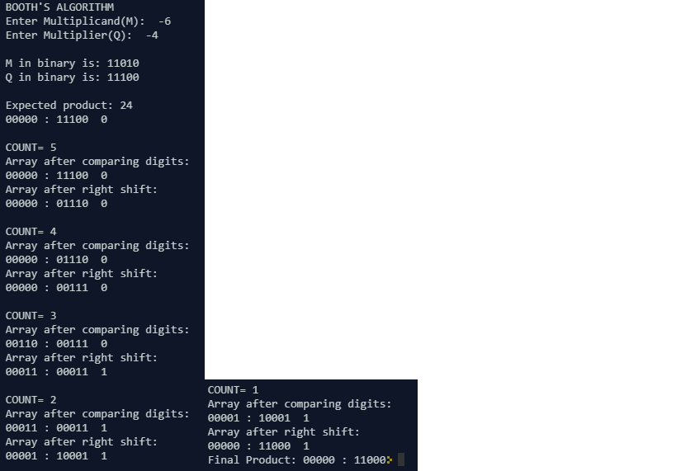
Example:
M=5 (0101)
Q=4 (0100)
M’s 2’s compliment: 1011
Count | A | Q | Q₋₁ | Operation
4 | 0000 | 0100 | 0
4 | 0000 | 0010 | 0 | Arithmetic Right Shift
3 | 0000 | 0001 | 0 | Arithmetic Right Shift
2 | 1011 | 0001 | 0 | A=A-M
2 | 1101 | 1000 | 1 | Arithmetic Right Shift
1 | 0010 | 1000 | 1 | A=A+M
1 | 0001 | 0100 | 0 | Arithmetic Right Shift

AQ=(00010100)₂=(20)₁₀.
Conclusion: The Booth’s Algorithm for multiplication was implemented in Java and the program ran successfully, giving desired output.

Post Lab Descriptive Questions (Add questions from examination point view)

1. Draw the Circuit diagram for booths algorithm.
Ans.
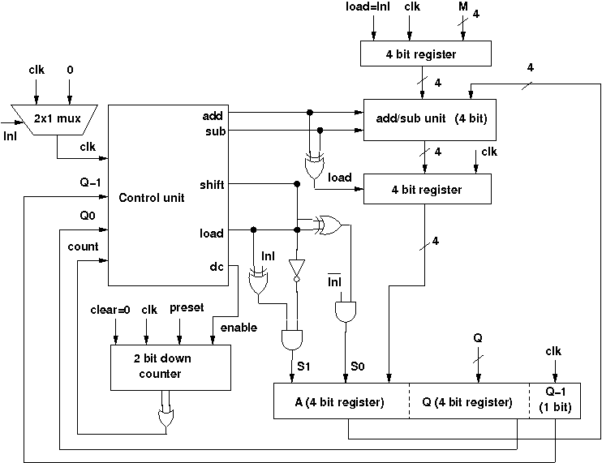
2. Explain advantages and disadvantages of Booth’s Algorithm.
Ans. Advantages:
- It reduces the number of partial products to be compressed in a carry-save added tree.
- It is very fast for multiplications having long operands (>16 bits).
- Not many conversions are required (only 2’s complement used).
Disadvantages:
- A lot of complexity is involved in the circuit to generate a partial product bit in Booth’s encoding.
- Algorithm is inefficient for isolated 1’s.
- Inconvenient for designing a synchronous multiplier.

Date: 01/08/2018 Signature of faculty in-charge

